Ejercicio 1

A= {3,5,7,9}

B= {1,2,3,4,5}

C= {4,5,6,7,8}

AUB= {3,5}

AUC= {5,7}

BUC= {4,5}

Ejercicio 2

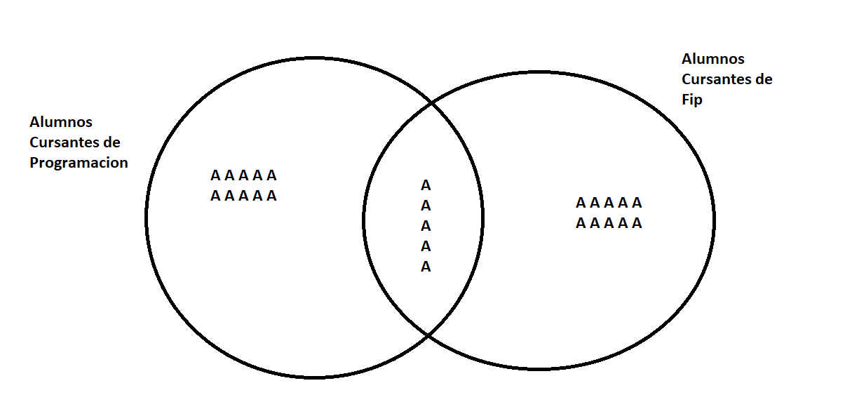

Ejercicio2.1

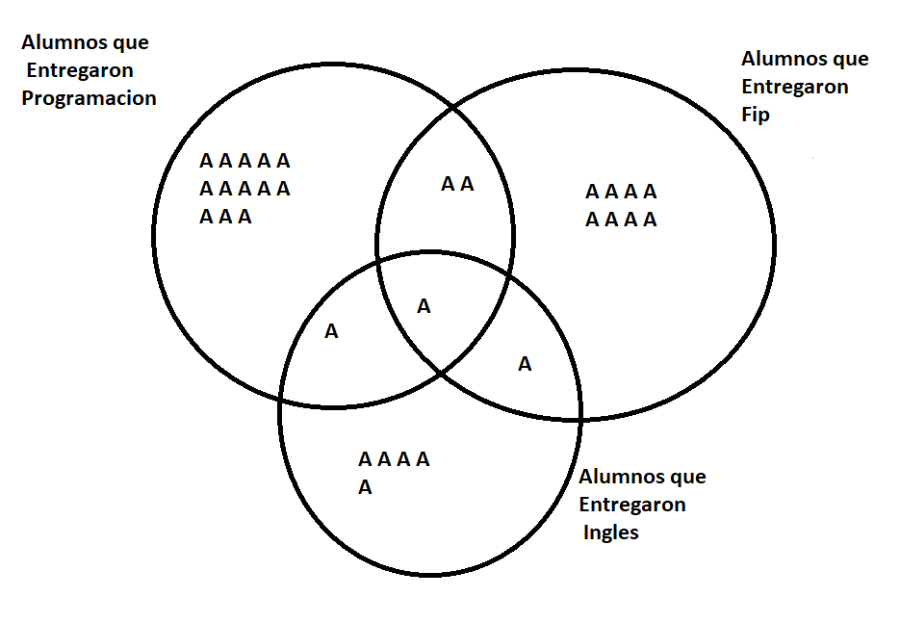

Ejercicio3

1. A{1,3,5,6,7}.
2. B{1,4,6,8,9,11,13}.
3. U{1,2,3,4,5,6,7,8,9,10,11,12,13}.
4. AuB{1,3,4,5,6,7,8,9,11,13}.
5. AnB{1,6}.
6. A-B{3,5,7}.
7. A+B{1,3,4,5,6,7,8,9,11,13}.
8. A△B{3,4,5,7,8,9,11,13}.
9. Ac{2,4,8,9,10,11,12,13}.